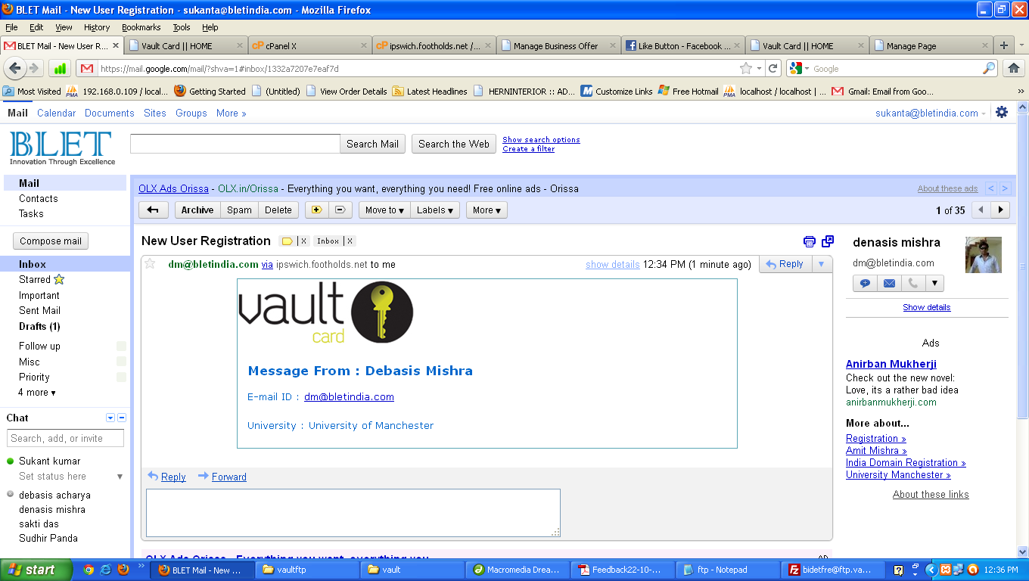

Registration is working fine in Mozilla Firefox. We have tested with our Email ID.

Receiver Email ID is given : [support@vaultcard.co.uk](mailto:support@vaultcard.co.uk)

After Registration all email with company logo will redirect to the above Email id.